

***A CRM APPLICATION FOR LAPTOP RENTALS***

From APSCHE

Name: P V Naveen

College: Government degree college autonomous rajamandry

Roll. No / Hall ticket. No: 2211146

**What Is Salesforce?**

Salesforce is your customer success platform, designed to help you sell, service, market, analyze, and connect with your customers.

Salesforce has everything you need to run your business from anywhere. Using standard products and features, you can manage relationships with prospects and customers, collaborate and engage with employees and partners, and store your data securely in the cloud.

But standard products and features are only the beginning. Our platform allows you to customize and personalize the experience for your customers, partners, and employees and easily extend beyond out-of-the-box functionality.

So where does CRM fit in with all of this? Let's start by defining what CRM is.

**What Is CRM?**

CRM stands for Customer Relationship Management. This technology allows you to manage relationships with your customers and prospects and track data related to all of your interactions. It also helps teams collaborate, both internally and externally, gather insights from social media, track important metrics, and communicate via email, phone, social, and other channels.

In Salesforce, all of this information is stored securely in the cloud. Let's take a closer look at how that works, using an example you might be familiar with—a spreadsheet.

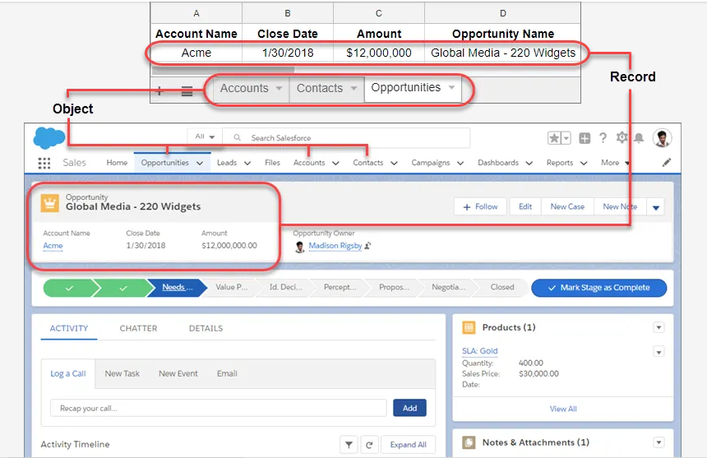

| Record | An item you're tracking in your database; if your data is like a spreadsheet, then a record is a row on the spreadsheet |
| --- | --- |
| Field | A place where you store a value, like a name or address; using our spreadsheet example, a field would be a column on the spreadsheet |
| Object | A table in the database; in that spreadsheet example, an object is a tab on the spreadsheet |
| Org | Short for “organization,” the place where all your data, configuration, and customization lives. You and your users log in to access it. You might also hear this called “your instance of Salesforce” |
| App | A set of fields, objects, permissions, and functionality to support a business process |

**LAPTOPS RENTAL PROJECT**

**Object Creation**

What Is an Object?

Salesforce objects are database tables that permit you to store data that is specific to an organization. What are the types of Salesforce Objects

Salesforce objects are of two types:

1. Standard Objects: Standard objects are the kind of objects that are provided by salesforce.com such as users, contracts, reports, dashboards, etc.

2. Custom Objects: Custom objects are those objects that are created by users. They supply information that is unique and essential to their organization. They are the heart of any application and provide a structure for sharing data.

**Create Total Laptops Object**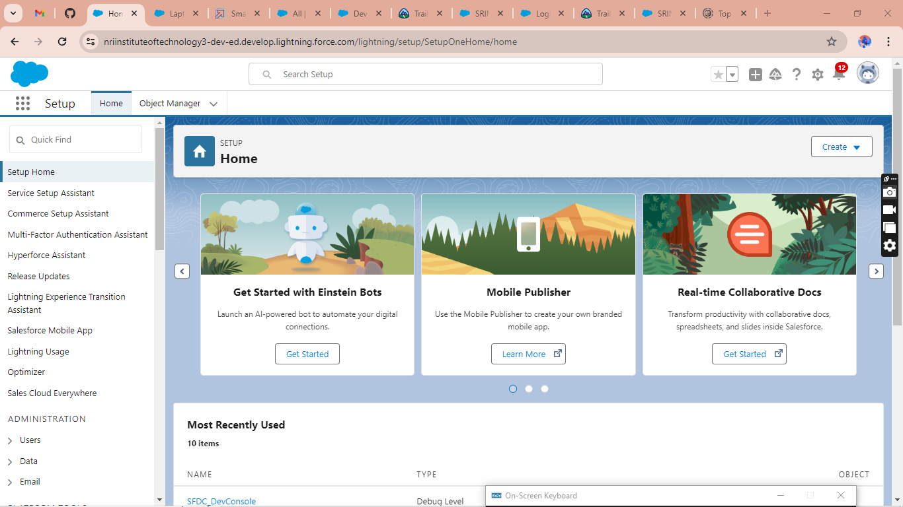

To Navigate to Setup page:

Click on gear icon - click setup

To create an object:

1.   From the setup page - Click on Object Manager - Click on Create - Click on Custom Object.

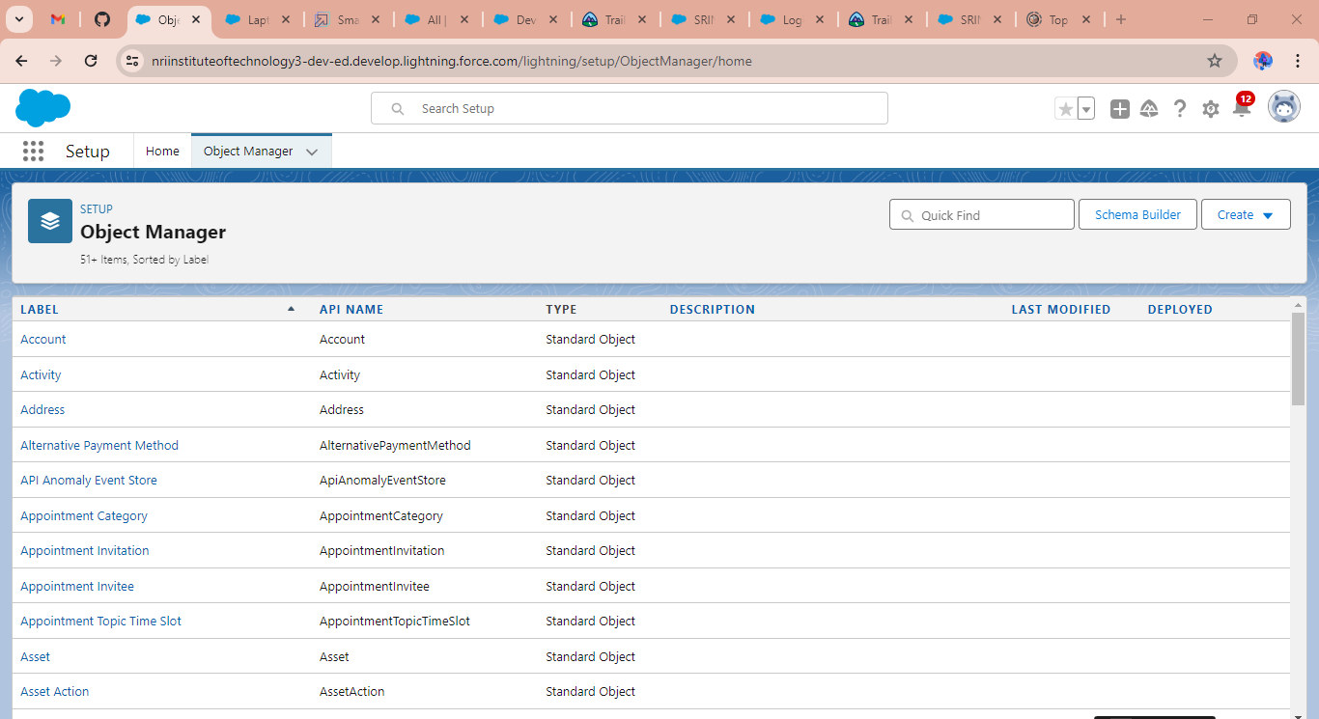

   Go To Create and Select Custom Object

Enter the label name- Total Laptops

2) Plural label name- Total Laptops

3) Enter Record Name Label and Format

   Record Name -Total Laptops

    Data Type - Text

1. Click on Allow reports, Allow search  and Track Field History,
2. Allow search - Save.

**LAPTOPS BOOKINGS OBJECT AND FIELDS &RELATIONSHIPS** 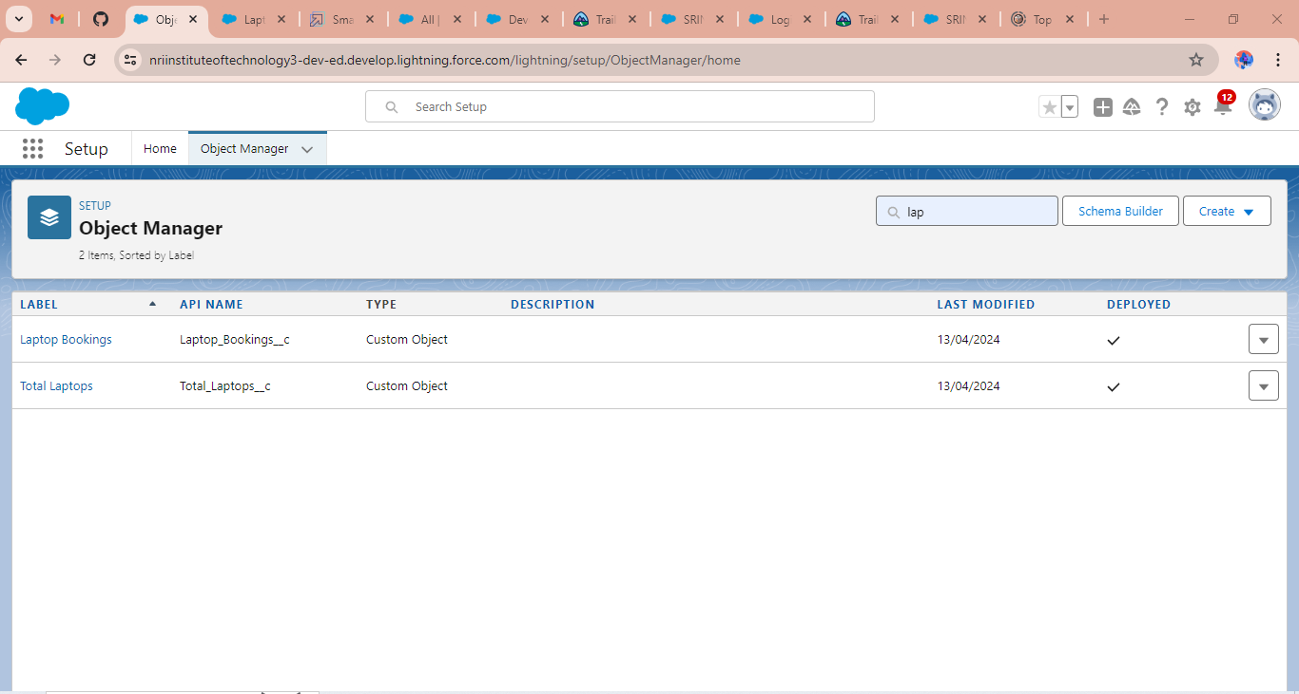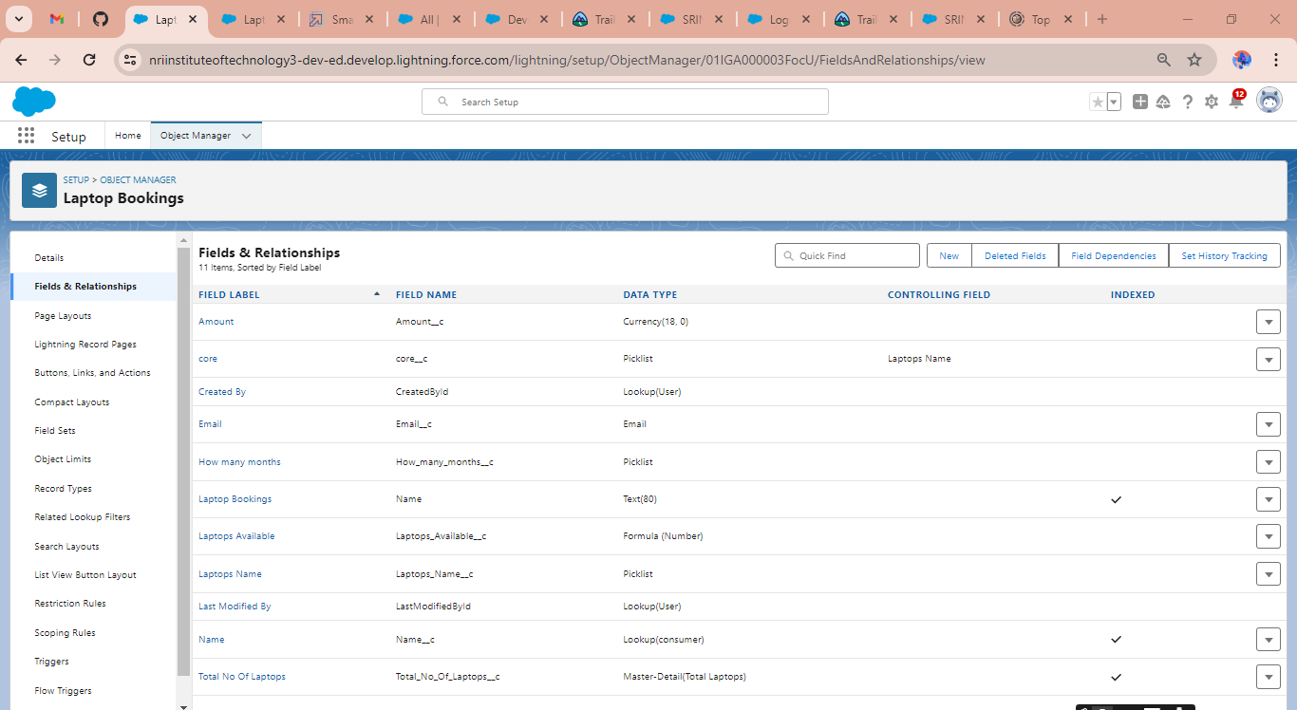



**TOTAL LAPTOPS OBJECT AND FIELDS &RELATIONSHIPS** 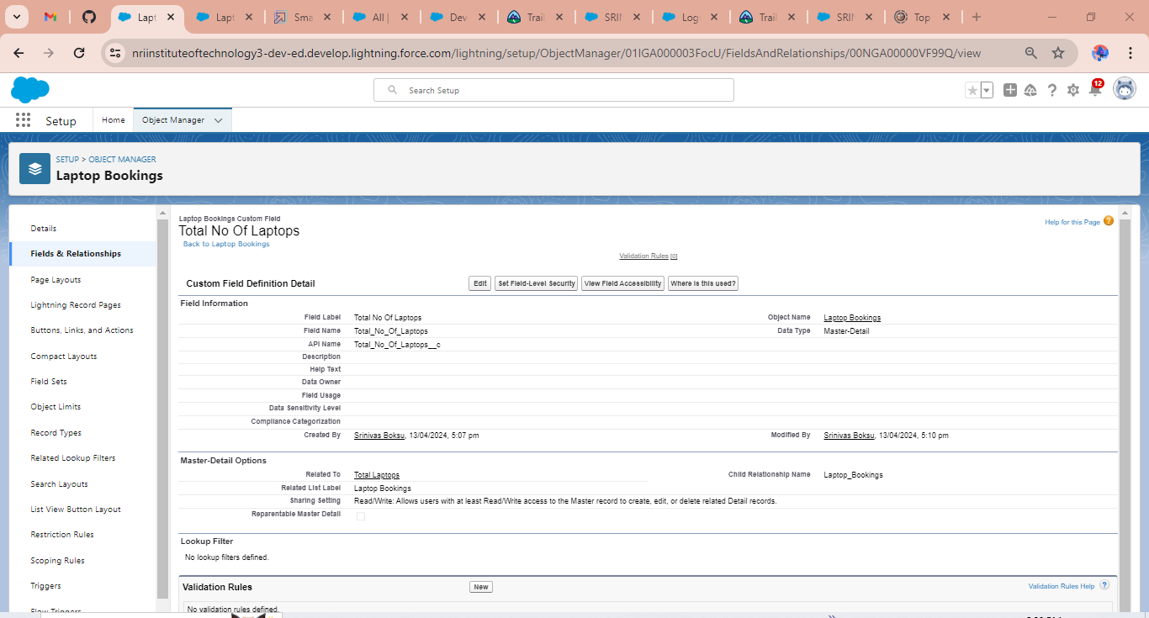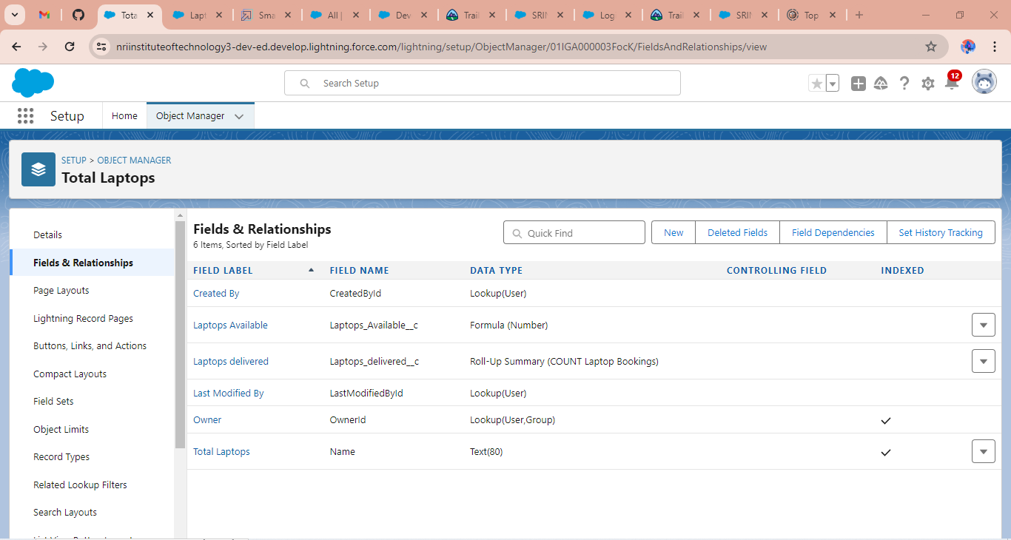

**CONSUMER OBJECT AND FIELDS &RELATIONSHIPS** 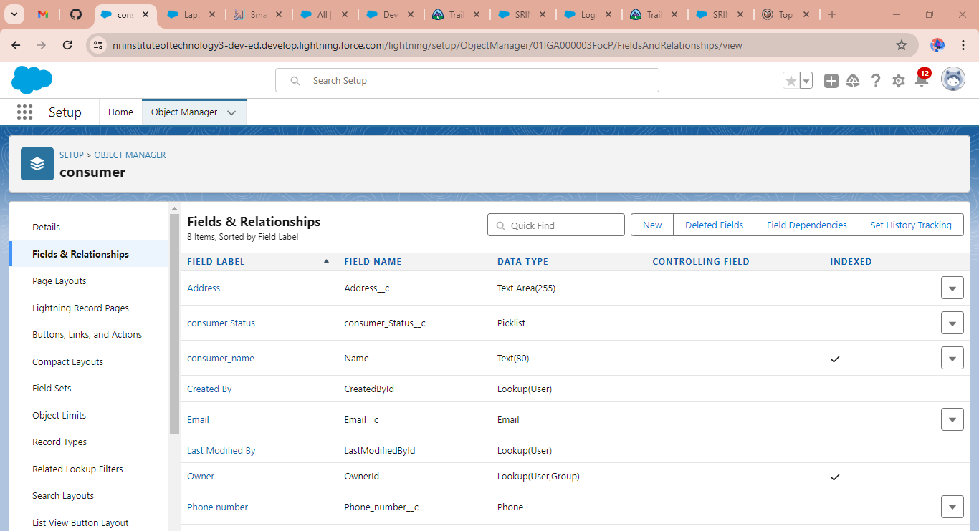

**BILLING PROCESS OBJECT AND FIELDS &RELATIONSHIPS** 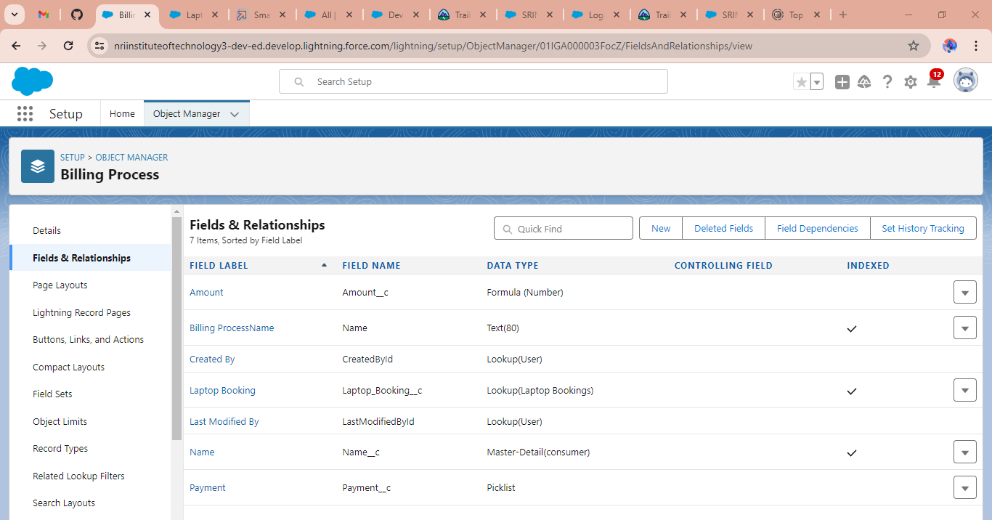

**CREATING TABS FOR CUSTOM OBJECTS**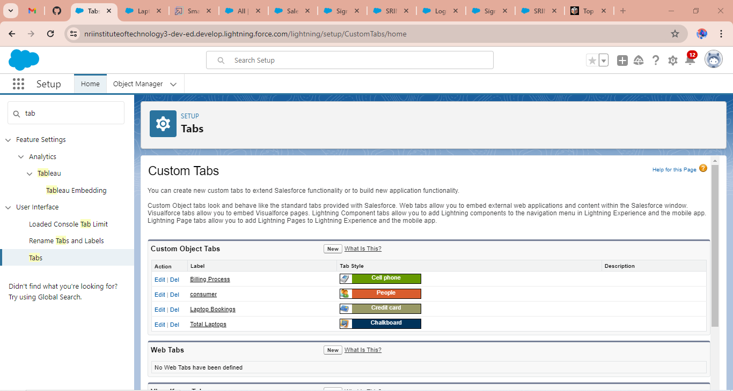

**APP MANAGER 🡪 NEW 🡪 NAME 🡪 NAVIGATION ITEMS 🡪 PROFILE 🡪SAVE**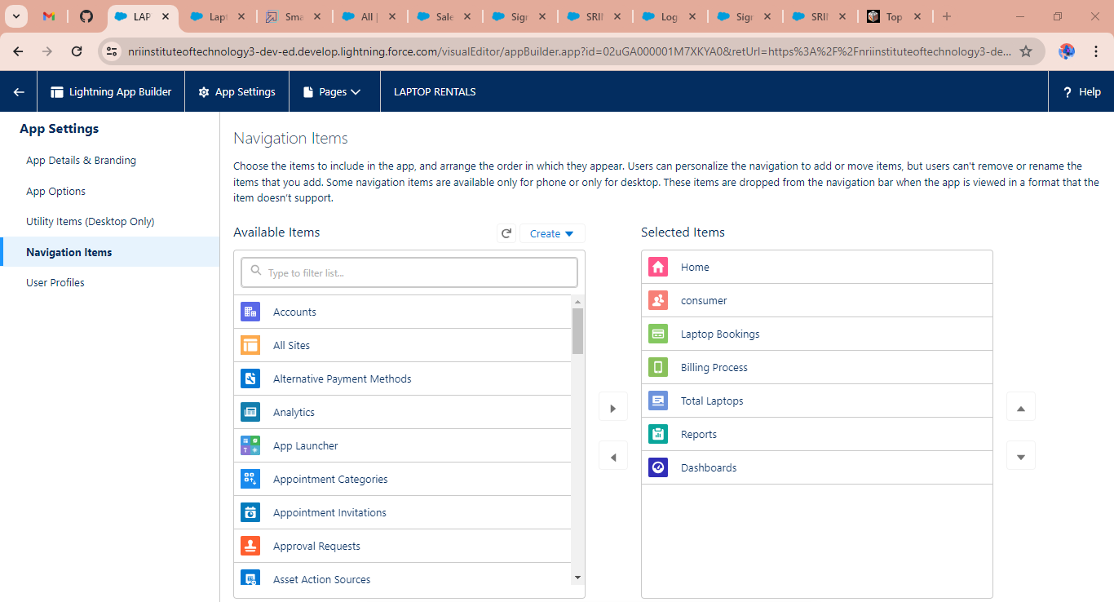

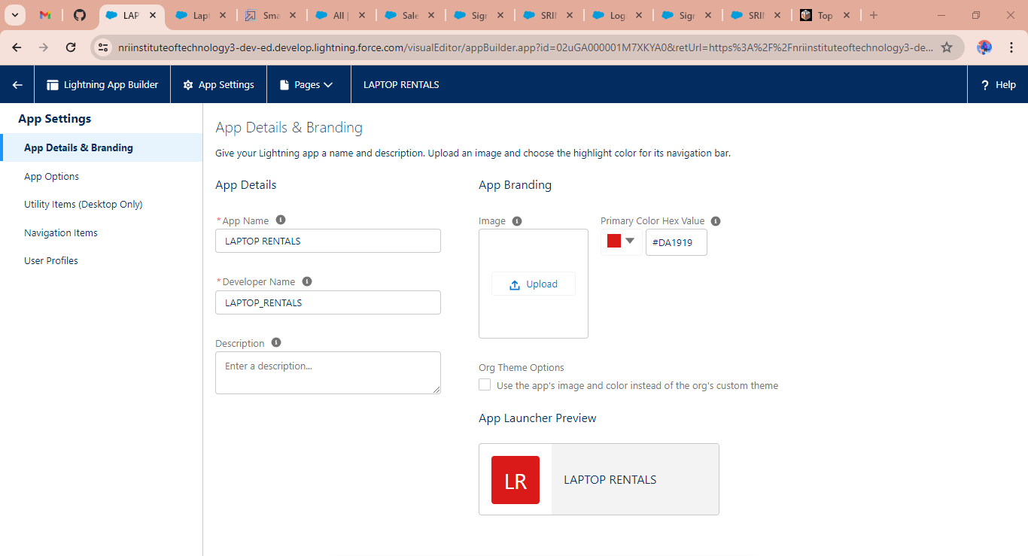

**CREATING PROFILES**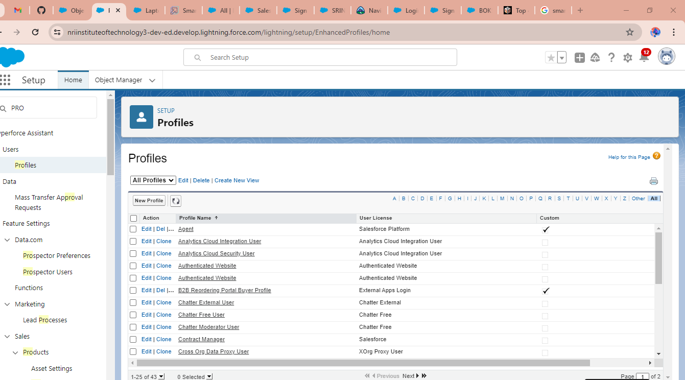

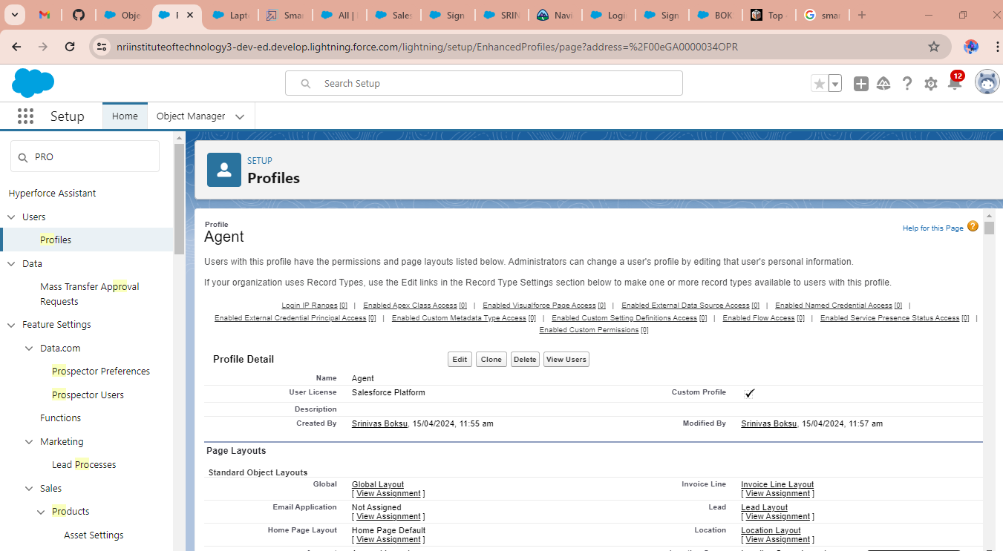

**OWNER PROFILE** 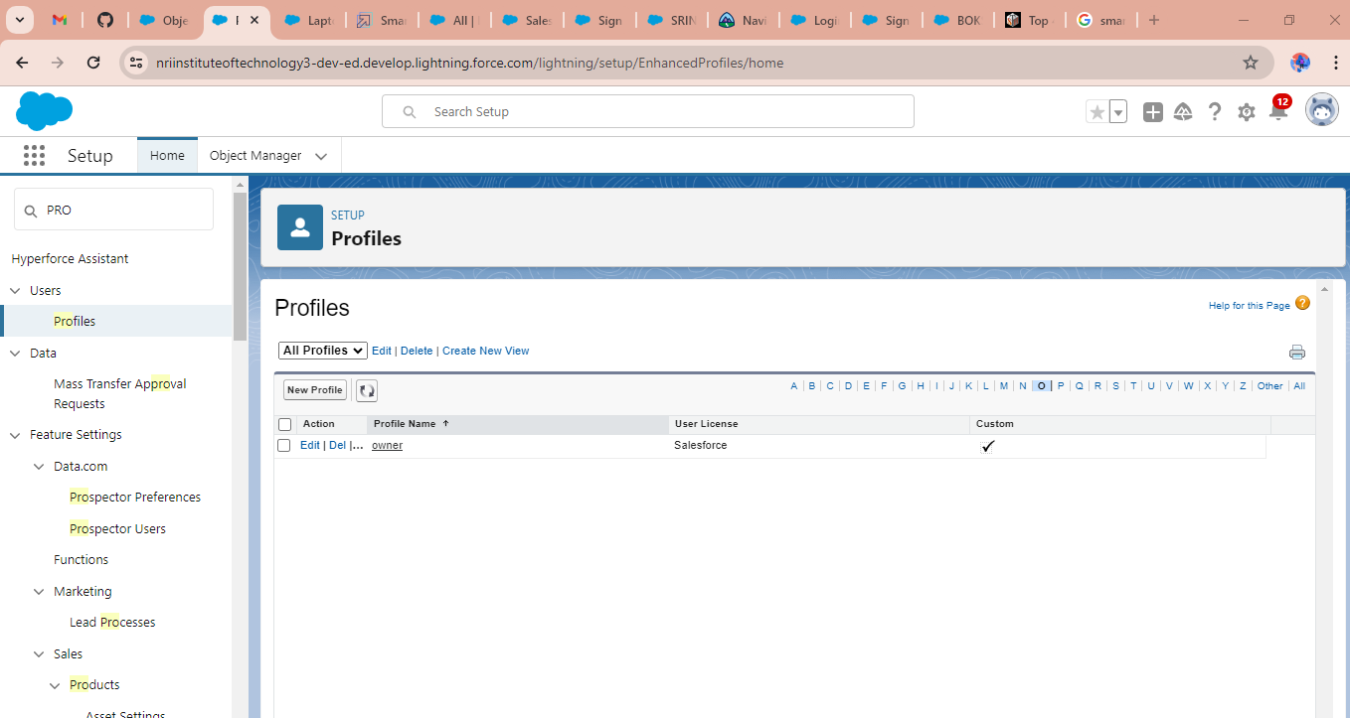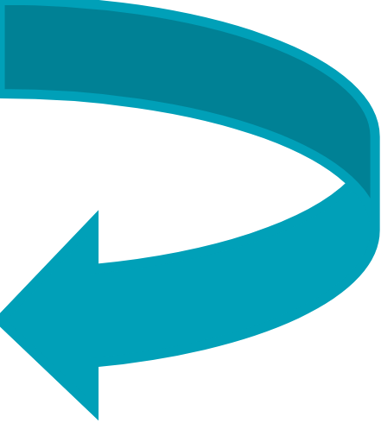

**CREATING USERS WITH PROFILES** 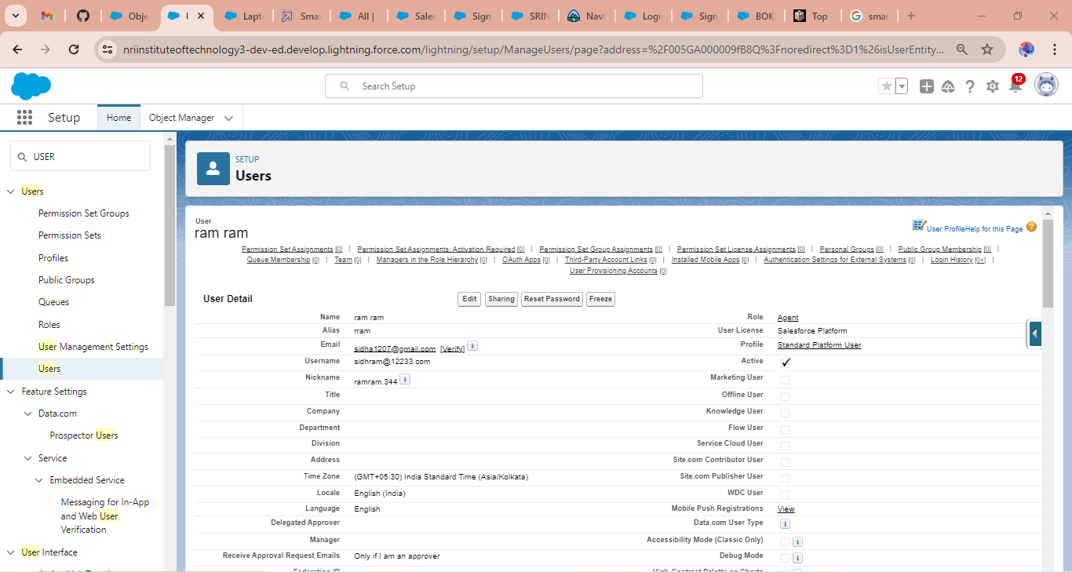

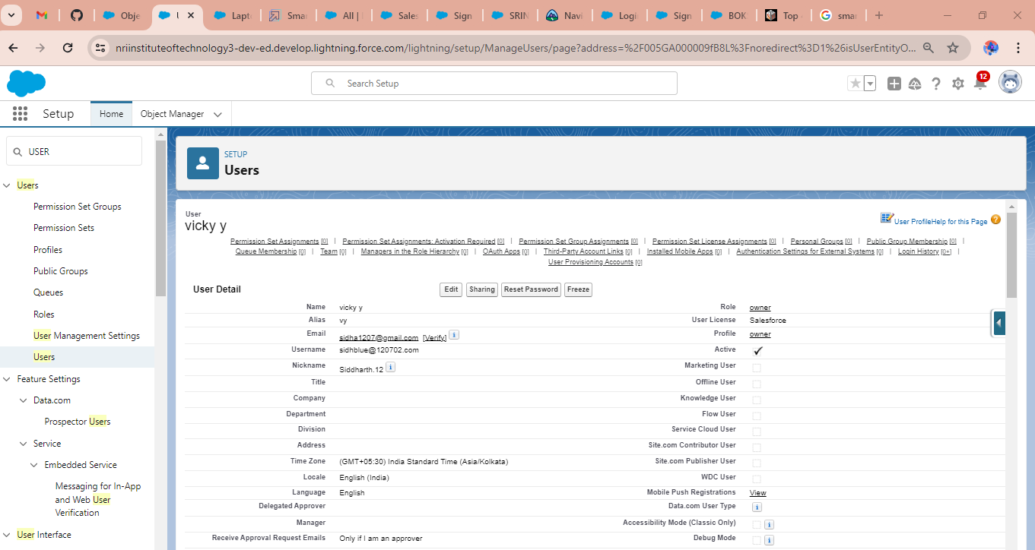

**LAPTOP DISTRIBUTION FLOW OVERVIEW** 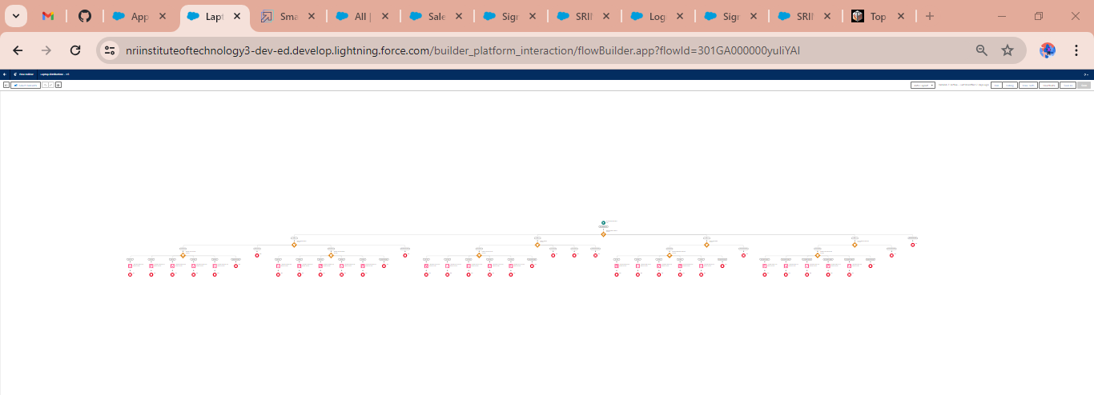

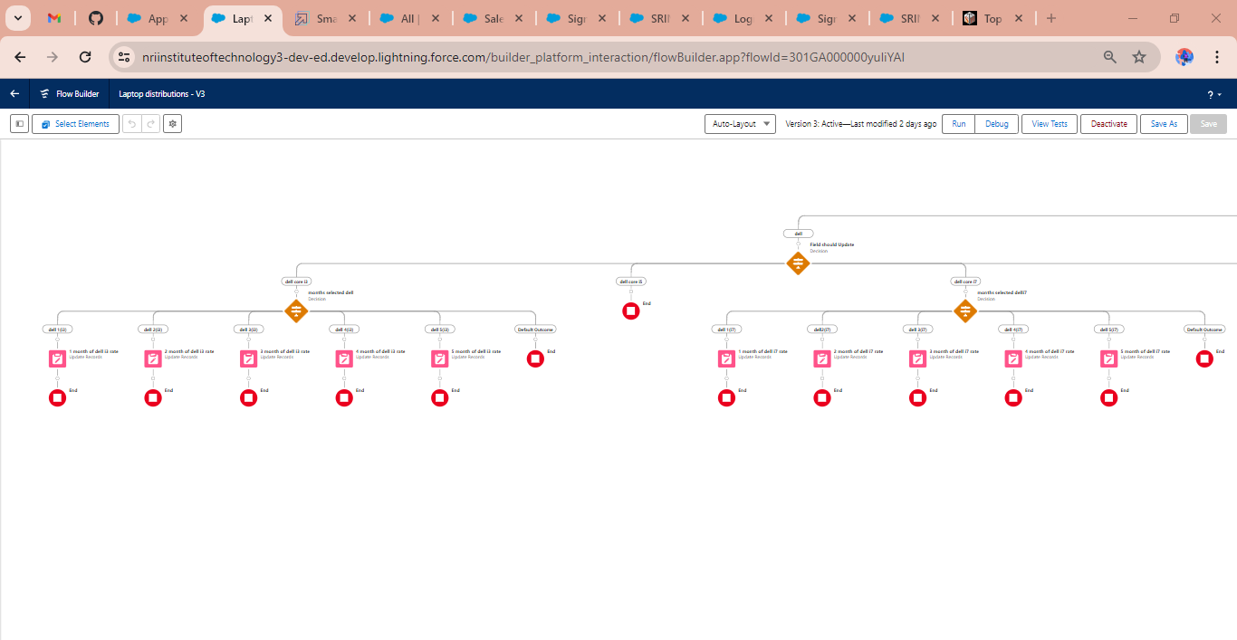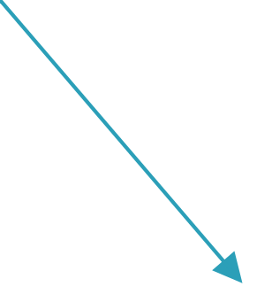

**FLOW FOR ACER LAPTOP** 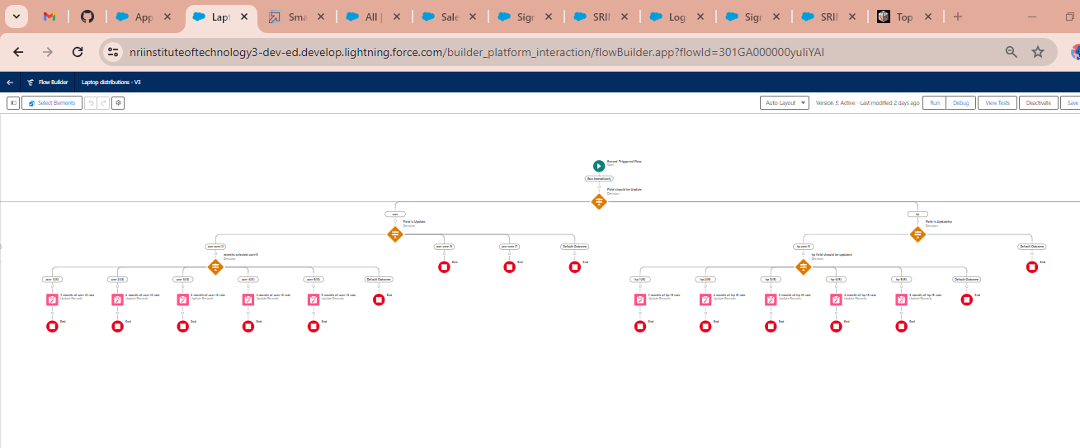

**FLOW FOR HP LAPTOP**

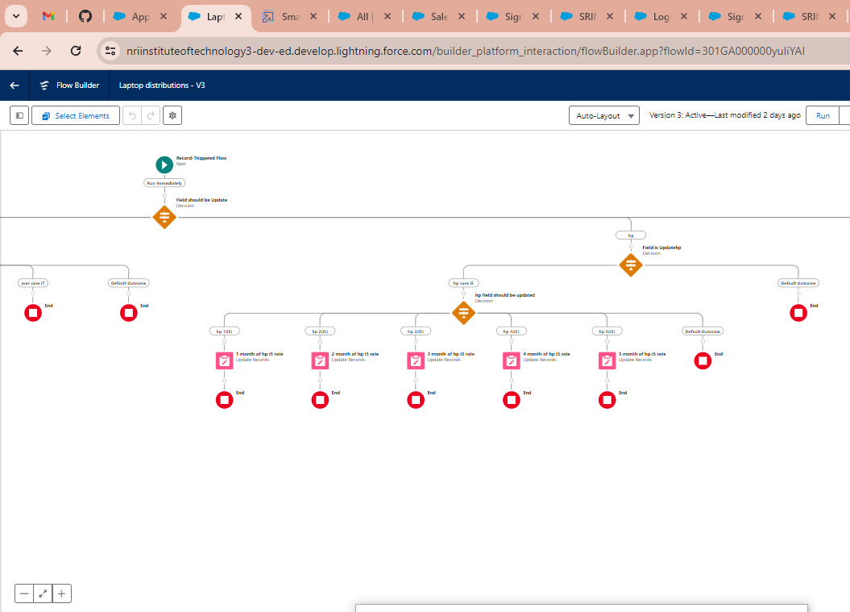

**FLOW FOR MAC BIONIC CHIP**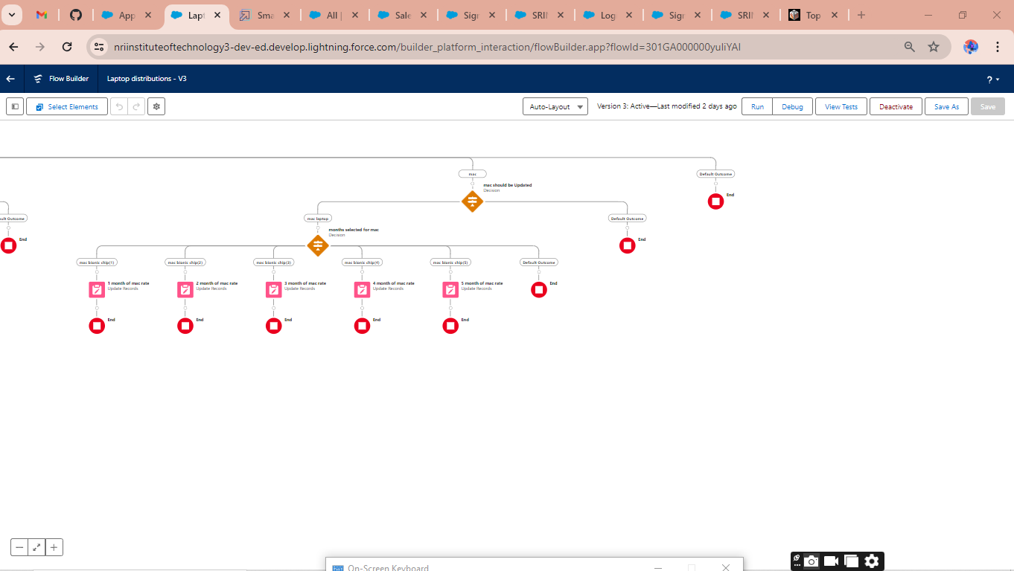

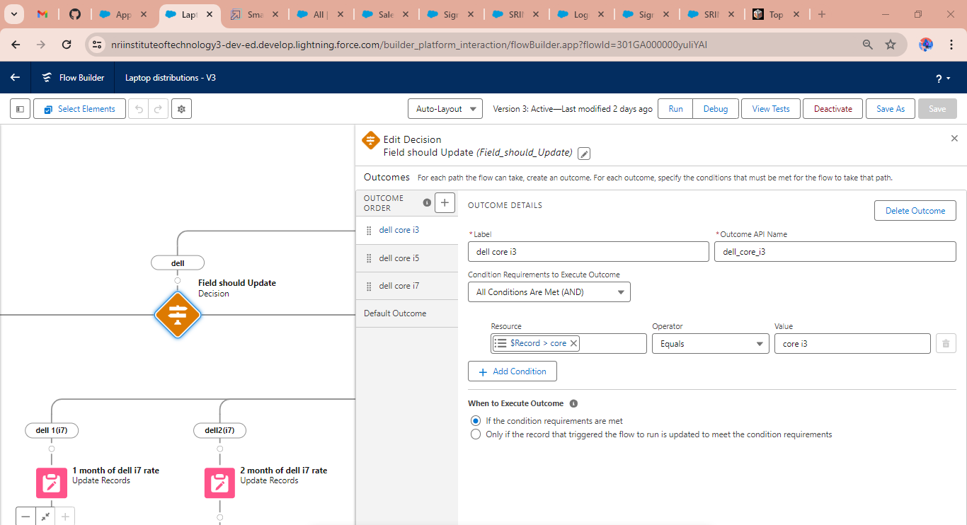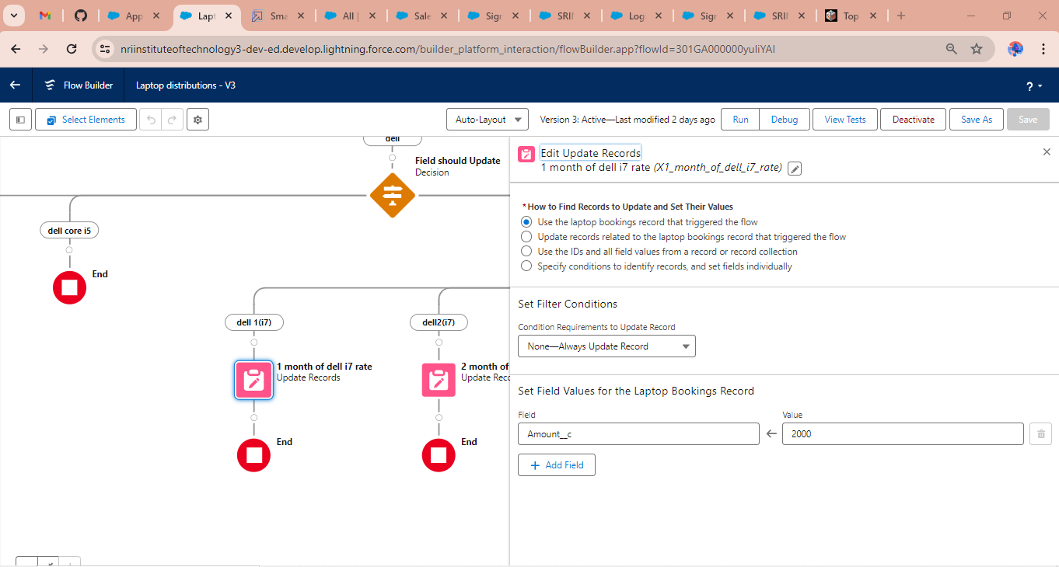

**hp core months selected** 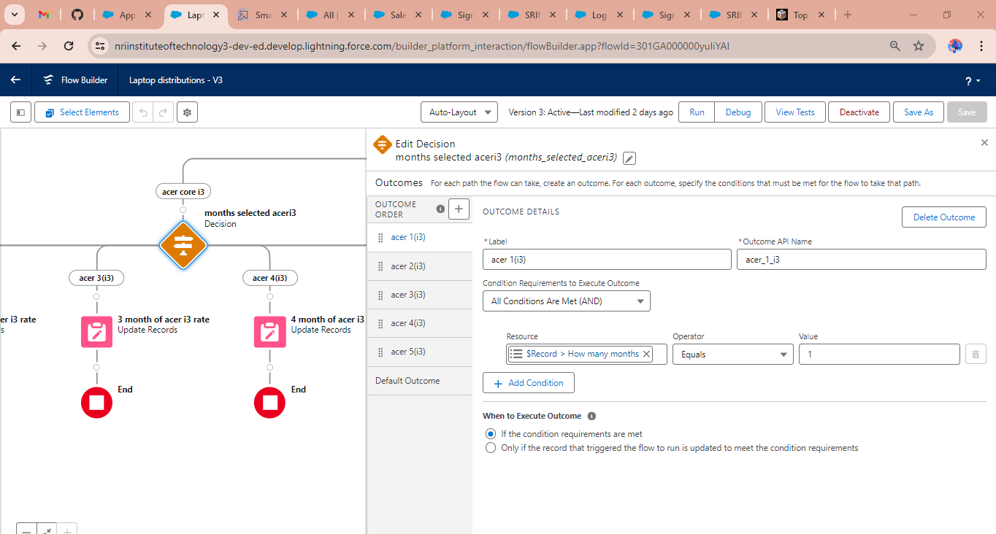

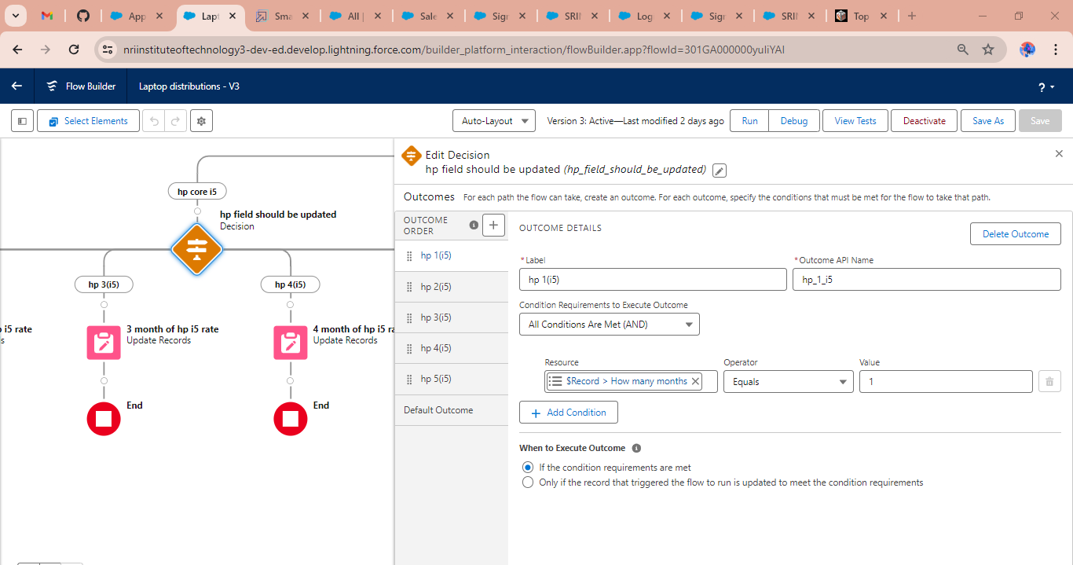

**Record Creating on Laptop Bookings Object** 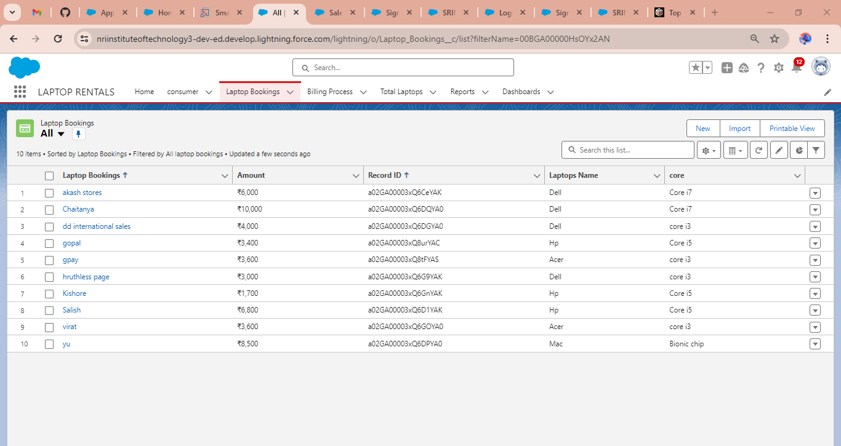

**Billing Process object** 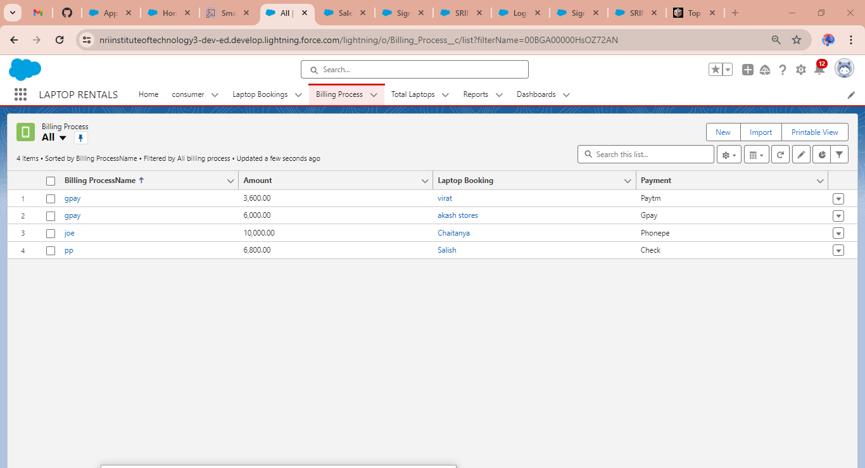

**SPLIT VIEW OF CONSUMER OBJECT** 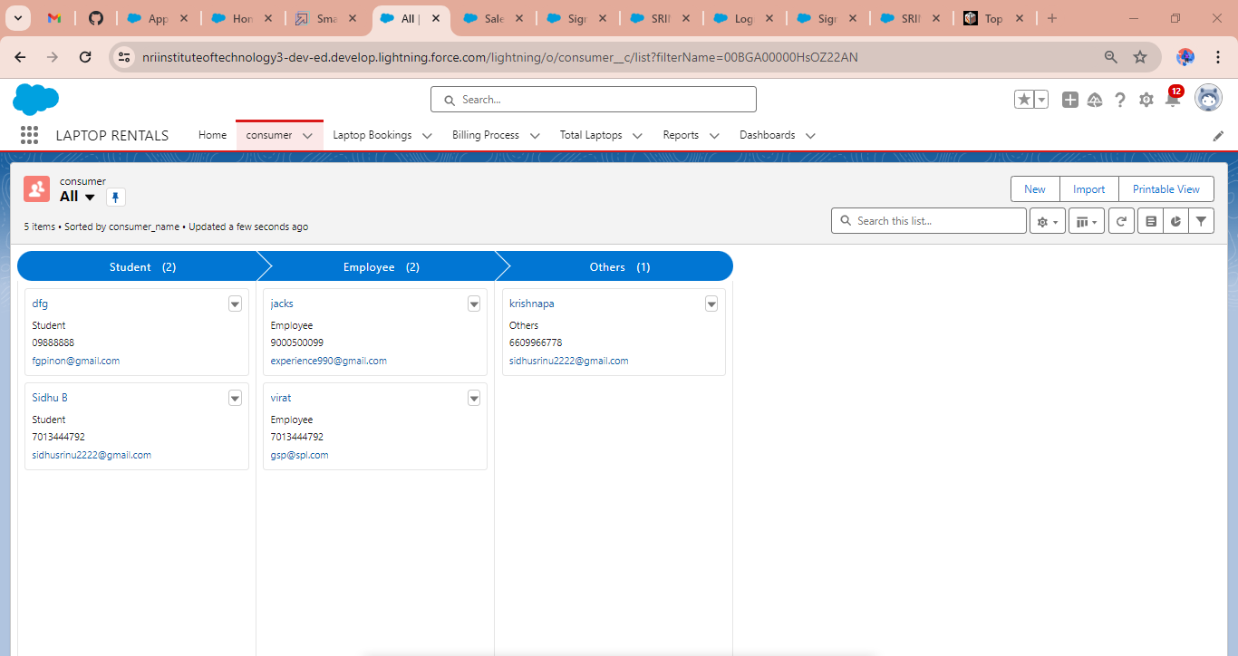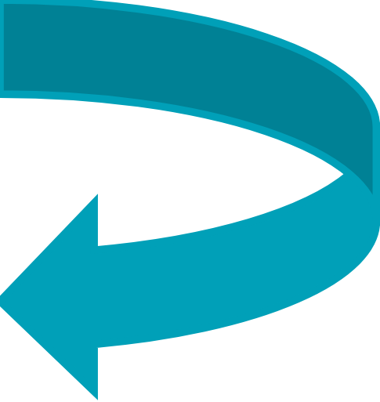

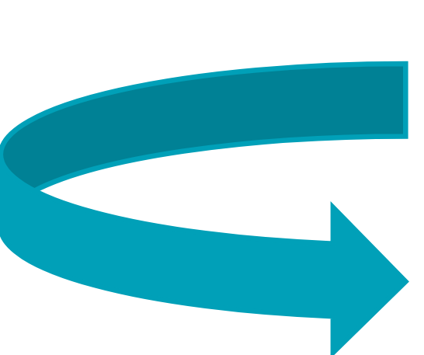

**CHATS IN APP**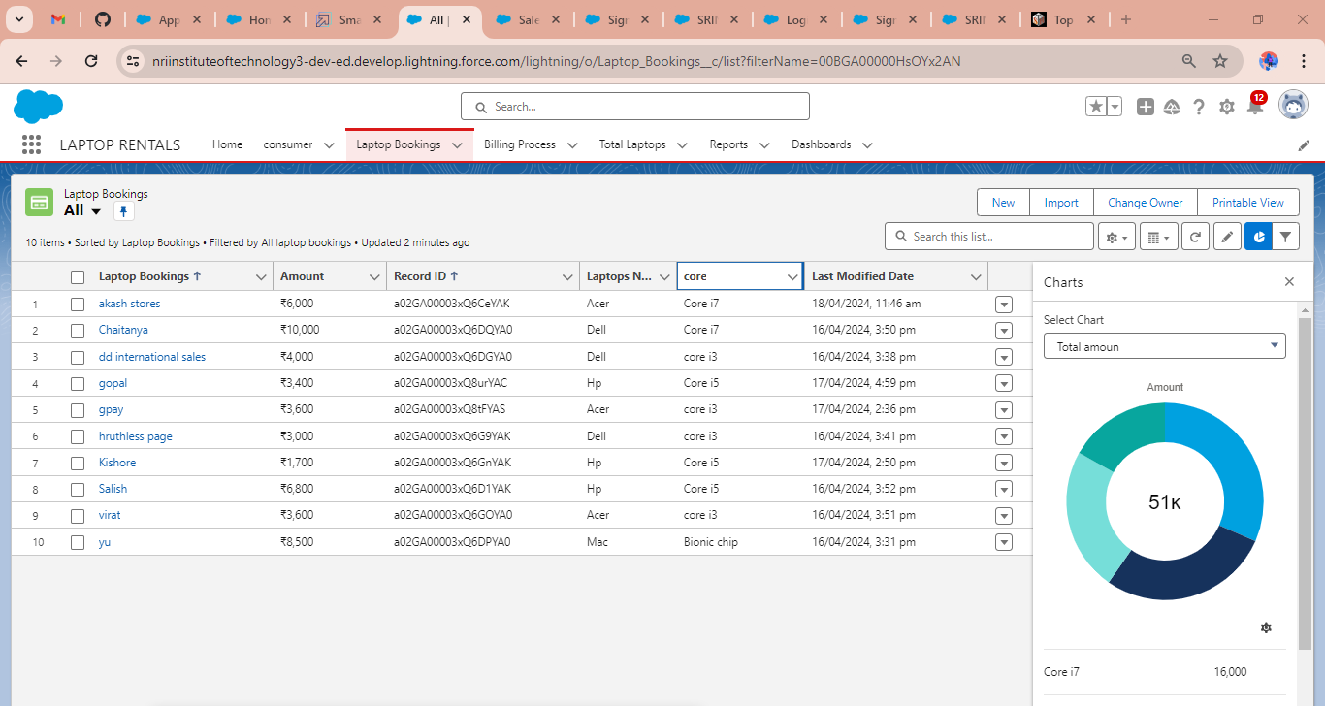

**Creating Reports on consumer with laptop booking** 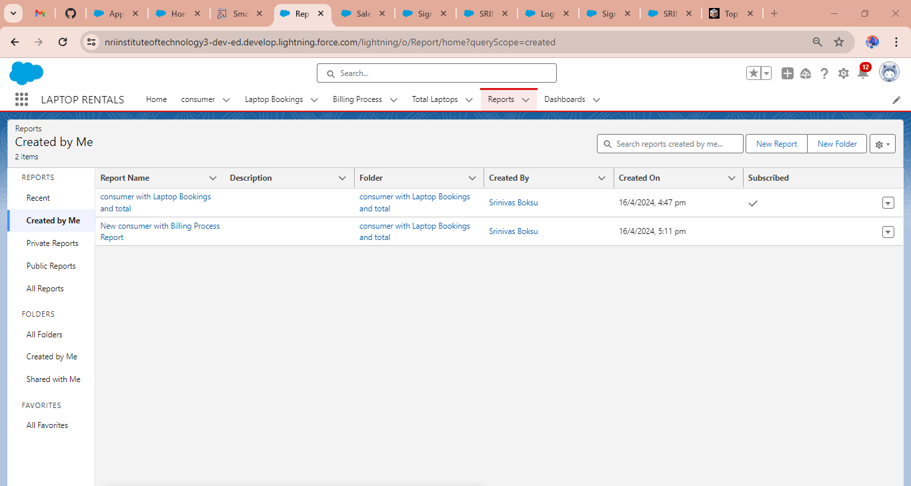

Select report type from category or from report type panel or from search panel “consumer with Laptop Bookings and total laptops” - click on start report.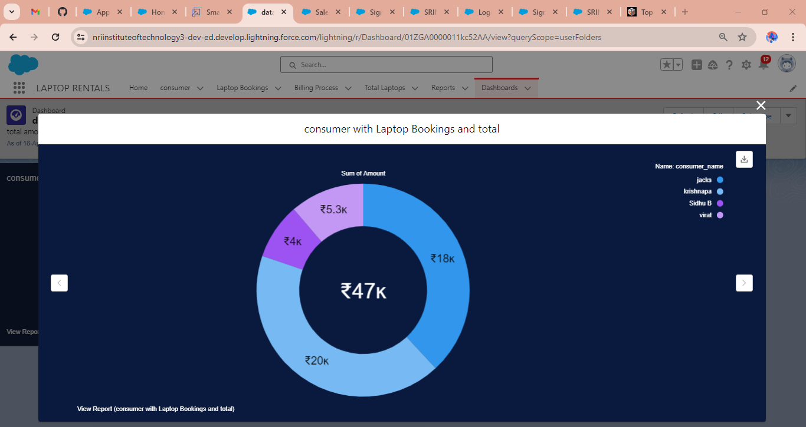

**Creating Dashboards on consumer with laptop booking**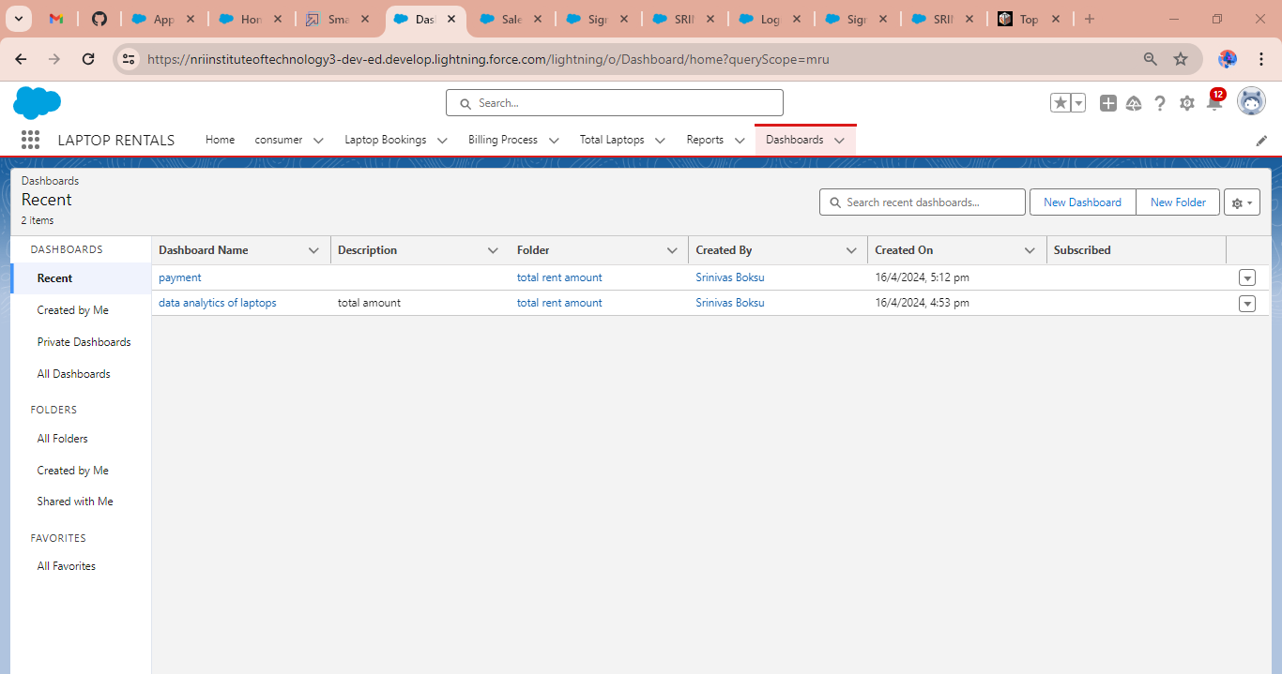

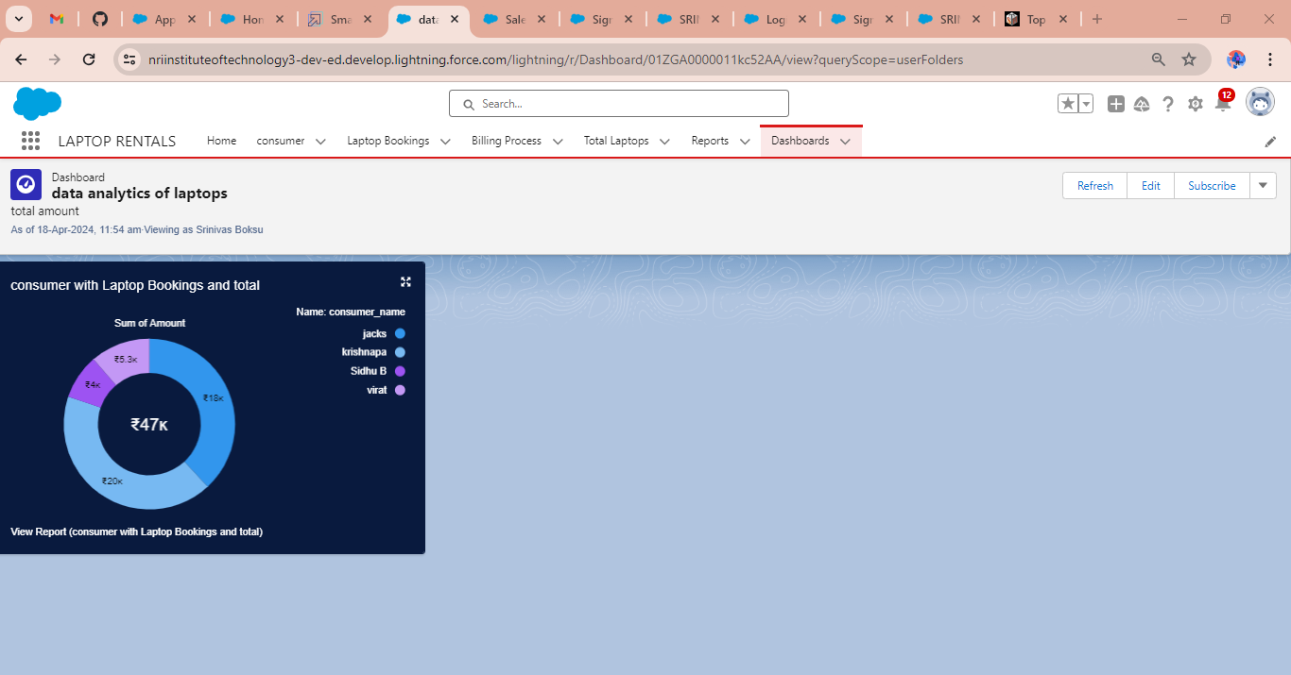

**TRIGGER ON APEX TO SEND A MAIL WHENEVER A RECORD IS CREATED OR UPDATED**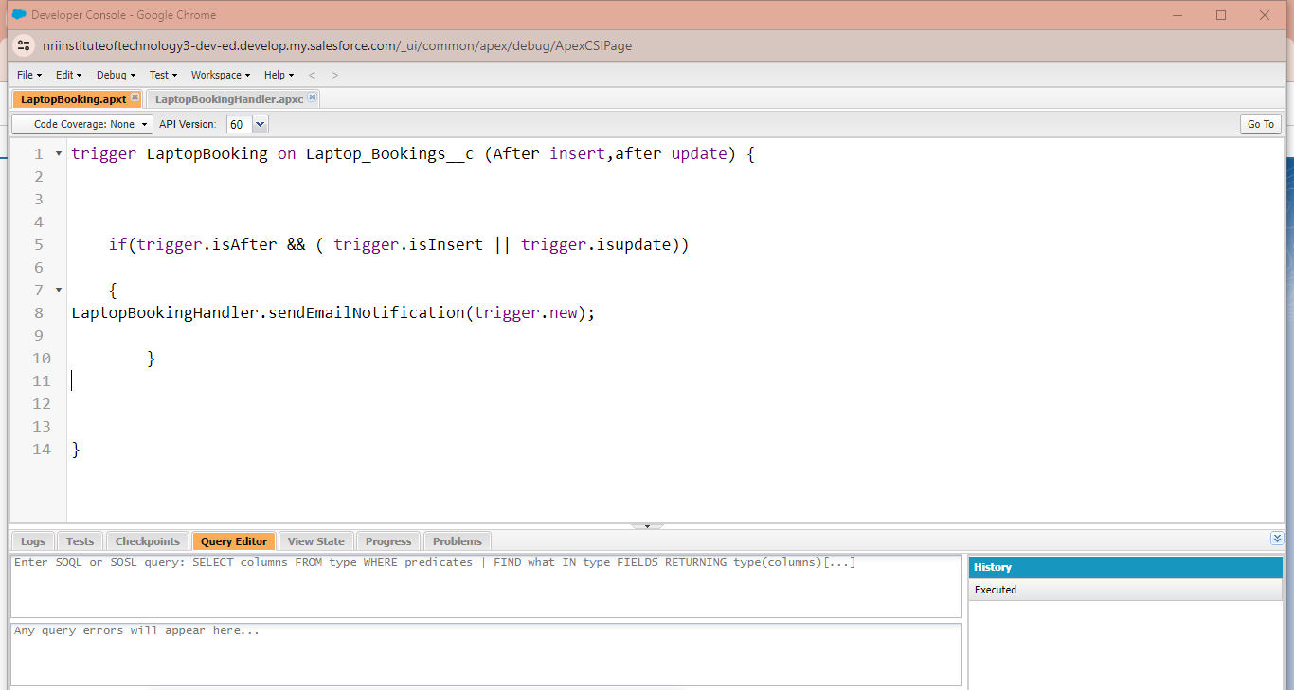

**APEX CODE TO SEND A MAIL WHENEVER A RECORD IS CREATED OR UPDATED**

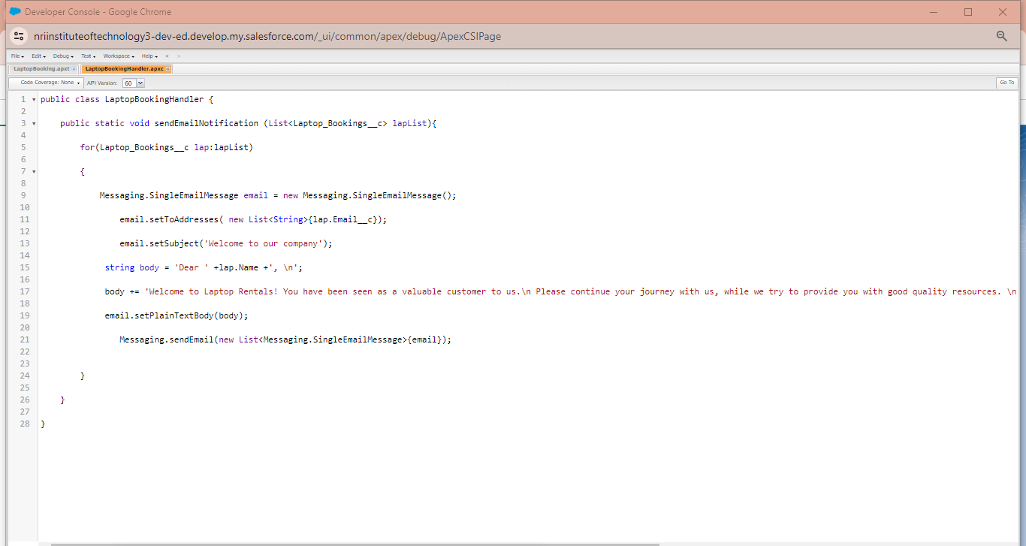

**EMAIL TO ACCOUNT WHEN LAPTOP BOOKING CREATED** 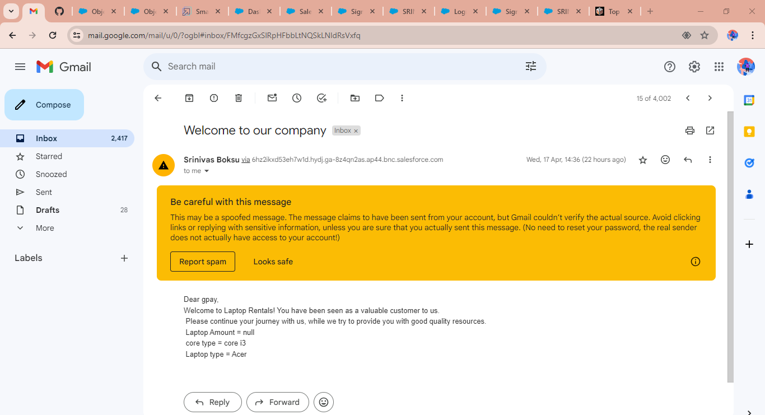

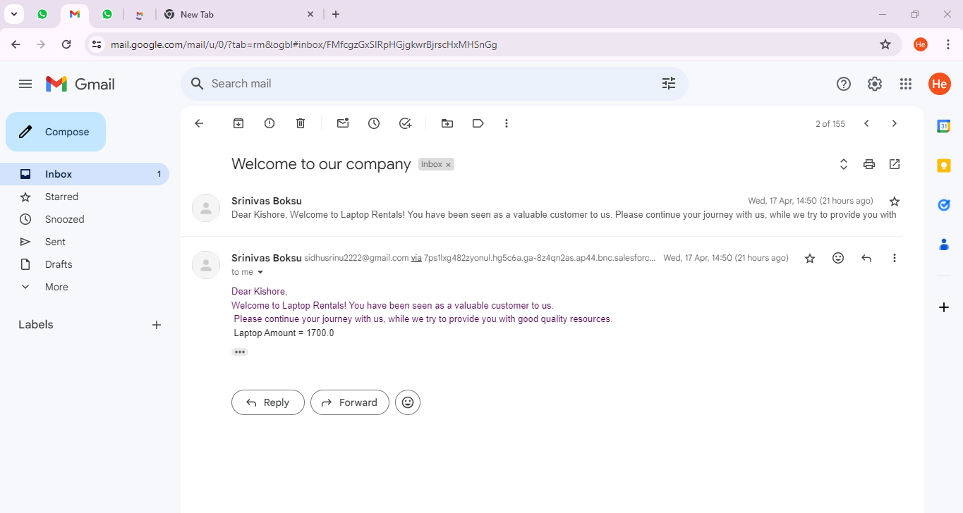

**DEVELOPER TRAILHEAD LINK:** [*https://nriinstituteoftechnology3-dev-ed.develop.lightning.force.com/lightning/setup/SetupOneHome/home*](https://nriinstituteoftechnology3-dev-ed.develop.lightning.force.com/lightning/setup/SetupOneHome/home)

*https://gemoo.com/tools/upload-video/share/639886180789264384?codeId=M0775p99elgXX&card=639886176628514816&origin=videolinkgenerator*